Jordan Ringenberg

EECS 6980
Bio Inspired Computing
Assignment
Max. Pts 20
- Design a Hopfield Neural Network to recognize the following two patterns.

- Describe the network architecture. How many neurons will it require? 5Pts

This network will require 16 neurons, one for each individual block of input. Each neuron will be connected to each other, requiring a 16 by 16 weight matrix (16^2 weights).

- Calculate the weight matrix. 5Pts
Using the following formula:
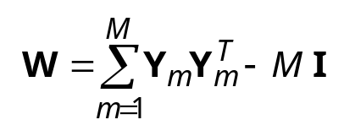
The weight matrix is defined as:

0 0 0 2 0 0 0 0 0 0 0 0 2 0 0 2
0 0 2 0 2 -2 -2 2 2 -2 -2 2 0 2 2 0
0 2 0 0 2 -2 -2 2 2 -2 -2 2 0 2 2 0
2 0 0 0 0 0 0 0 0 0 0 0 2 0 0 2
0 2 2 0 0 -2 -2 2 2 -2 -2 2 0 2 2 0
0 -2 -2 0 -2 0 2 -2 -2 2 2 -2 0 -2 -2 0
0 -2 -2 0 -2 2 0 -2 -2 2 2 -2 0 -2 -2 0
0 2 2 0 2 -2 -2 0 2 -2 -2 2 0 2 2 0
0 2 2 0 2 -2 -2 2 0 -2 -2 2 0 2 2 0
0 -2 -2 0 -2 2 2 -2 -2 0 2 -2 0 -2 -2 0
0 -2 -2 0 -2 2 2 -2 -2 2 0 -2 0 -2 -2 0
0 2 2 0 2 -2 -2 2 2 -2 -2 0 0 2 2 0
2 0 0 2 0 0 0 0 0 0 0 0 0 0 0 2
0 2 2 0 2 -2 -2 2 2 -2 -2 2 0 0 2 0
0 2 2 0 2 -2 -2 2 2 -2 -2 2 0 2 0 0
2 0 0 2 0 0 0 0 0 0 0 0 2 0 0 0

- Test if these two patterns are classified correctly with that weight matrix. 5pts

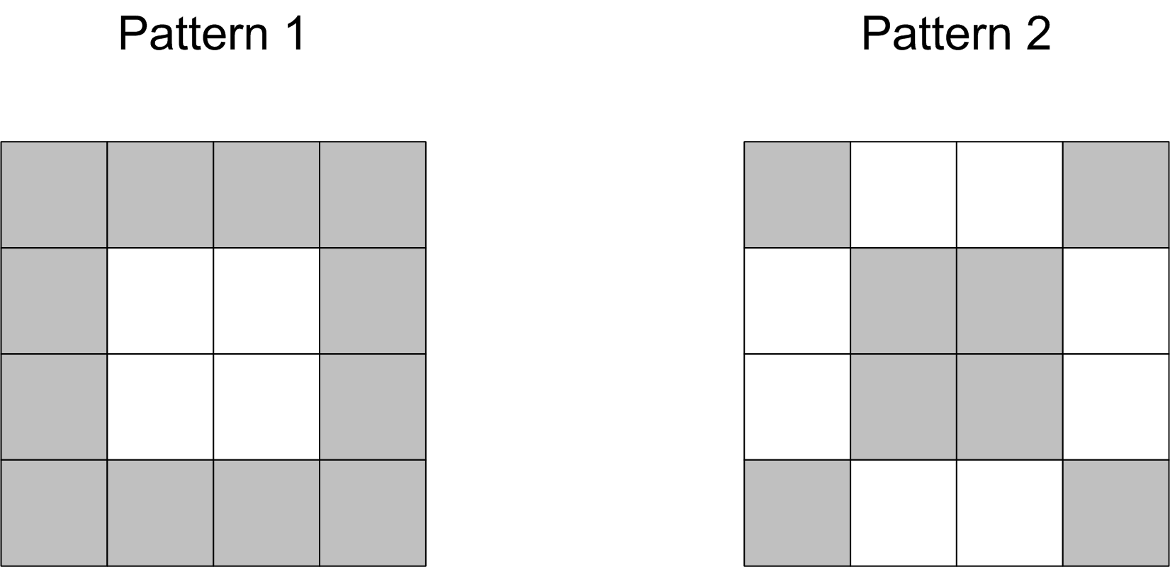

The following shows the results of the patterns being classified correctly when presented to the weight matrix:

1 1 1 1
1 -1 -1 1
1 -1 -1 1
1 1 1 1
1 -1 -1 1
-1 1 1 -1
-1 1 1 -1
1 -1 -1 1

- If a new pattern is given as shown in Fig. 2, to which category it will be classified? 5Pts
Converting the following pattern into the input vector:

[1 -1 -1 -1 -1 1 -1 -1 -1 -1 1 -1 -1 -1 -1 1]

and presenting it to the weight matrix, it is effectively classified into pattern 2.

